District Summary:  
**Before**



**After dropping reading and math score for Thomas High School ninth graders.**

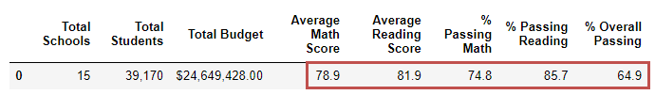

**Notes:** *The ninth graders rows for Thomas High School weren’t dropped. We just didn’t consider their math and reading scores. So, you will notice the total students doesn’t change and likewise other related data elements.*

School Summary:  
**Before**

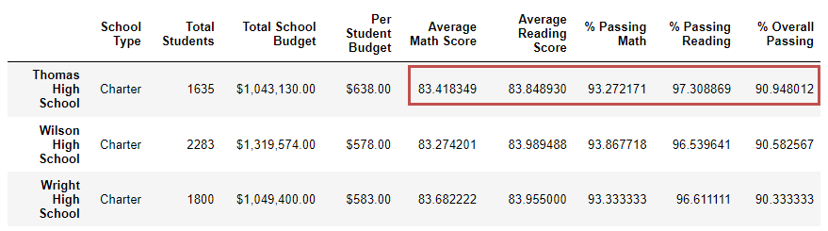

**After dropping reading and math score for Thomas High School ninth graders.**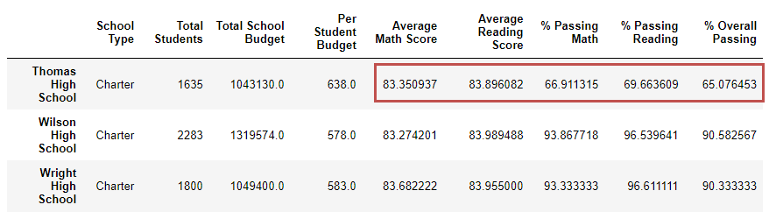

Top 5 Schools:   
**Before**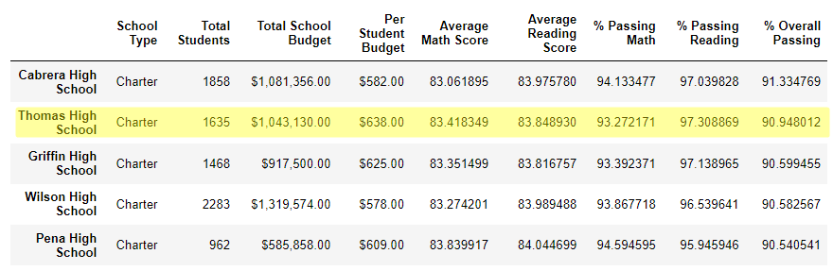

**After dropping reading and math score for Thomas High School ninth graders.**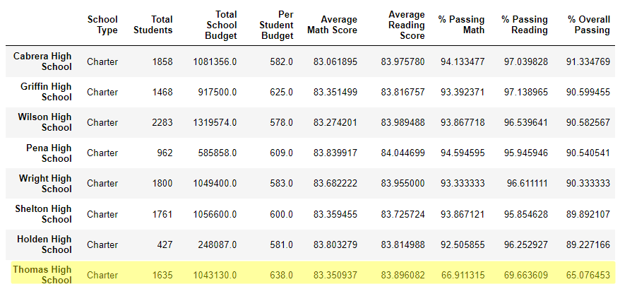

Bottom 5 Schools:   
**Before**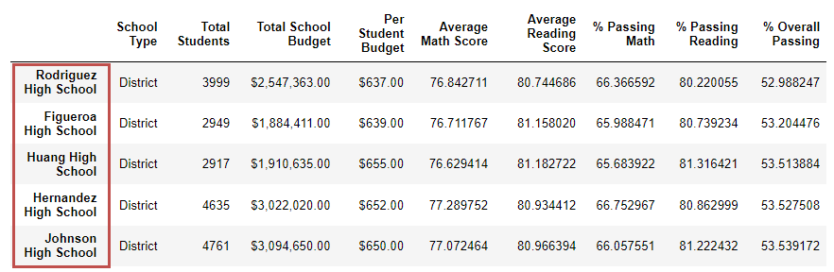

**After dropping reading and math score for Thomas High School ninth graders.**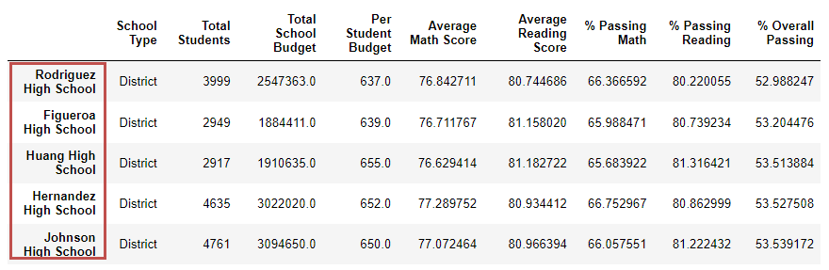

The Average Math Scores:  
**Before After dropping reading and math score for Thomas High   
 School ninth graders.**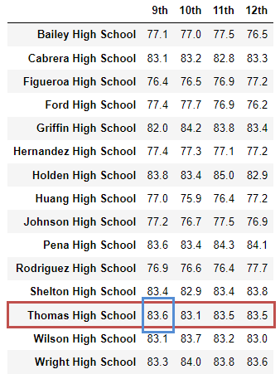 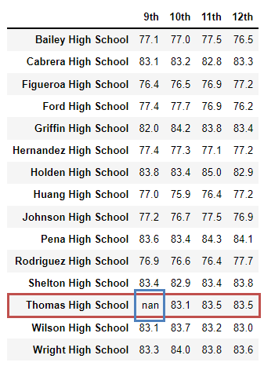

The Average Reading Scores:  
**Before After dropping reading and math score for Thomas High   
 School ninth graders.**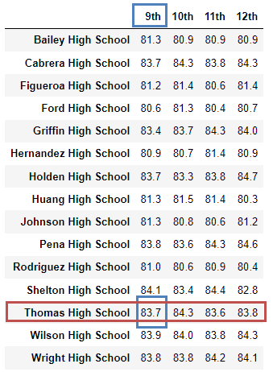 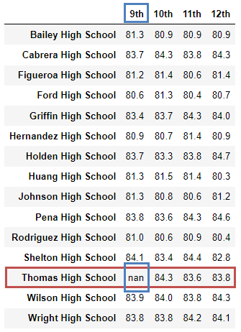

The Scores by School Spending Per Student:  
**Before After dropping reading and math score for Thomas High School   
 ninth graders.**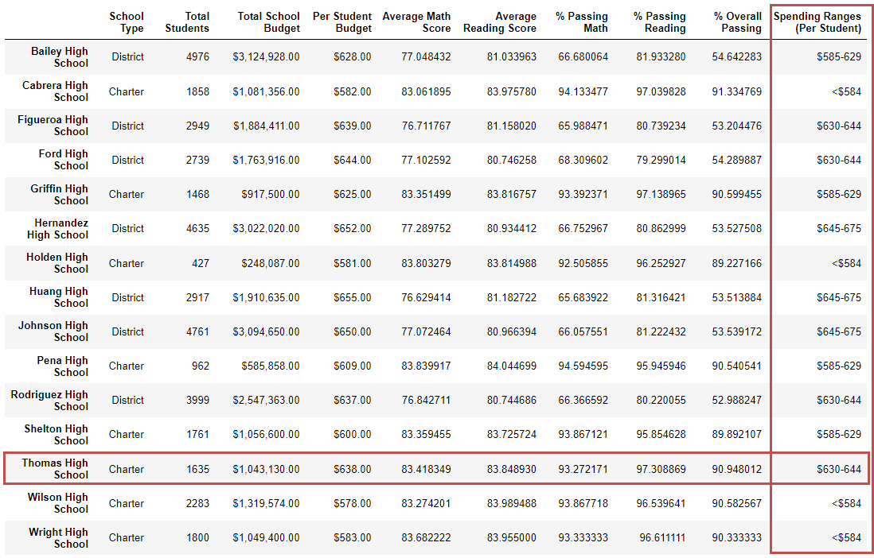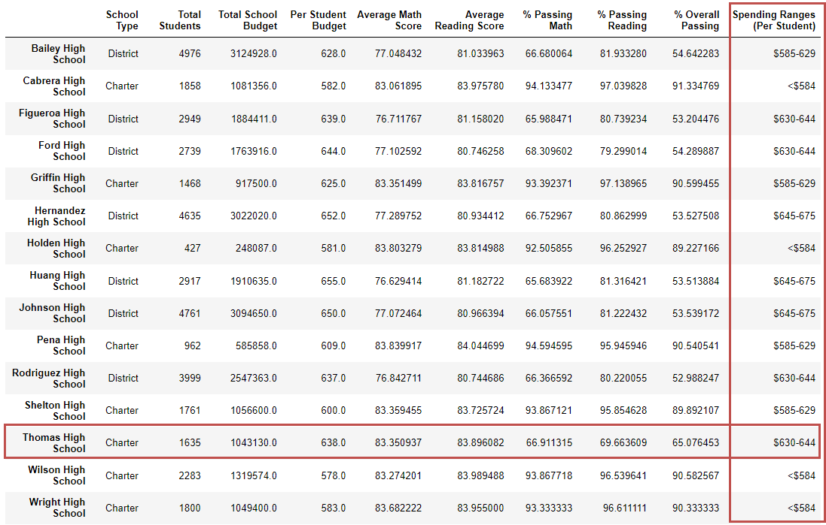

**Before**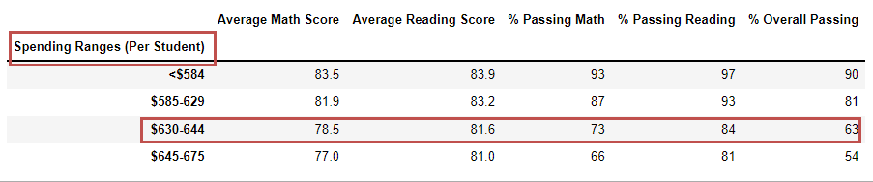

**After dropping reading and math score for Thomas High School ninth graders.**

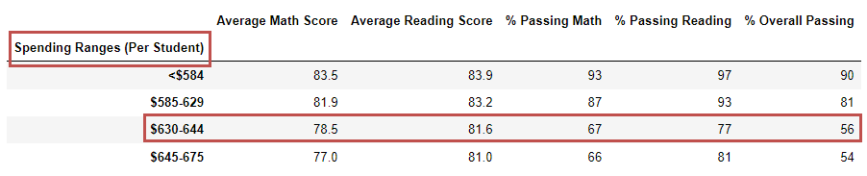

The Scores by School Spending by School Size:  
**Before**

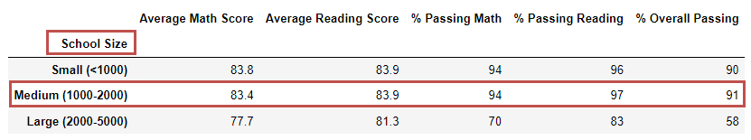

**After dropping reading and math score for Thomas High School ninth graders.**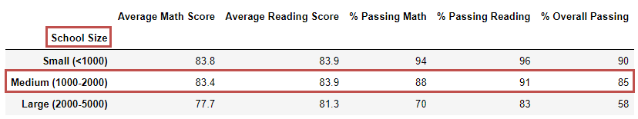

The Scores by School Spending by School Type:  
**Before**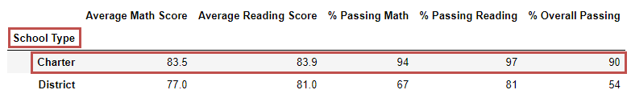

**After dropping reading and math score for Thomas High School ninth graders.**